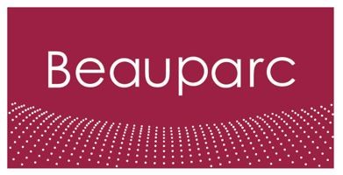
Job Description – Beauparc
Job Title | Semi skilled Fabricator/Welder
Reports to | Fabrications Manager
Primary Location | Cross Green – LS9 0SE

Purpose:
Embark on a rewarding career as an Semi Skilled Fabricator/Welder with Beauparc. Join our dynamic team and continue to learn the art of fabricating and welding, contributing to the construction and maintenance of various structures and equipment.

Key accountabilities:
- Metal Fabrication: Assist in the fabrication of metal components according to engineering drawings.
- Welding Procedures: Learn and apply welding techniques to join metal parts securely.
- Quality Control: Ensure the quality and accuracy of fabricated components through inspections.
- Safety Compliance: Adhere to safety protocols and guidelines during fabrication and welding activities.
- Learning and Development: Engage actively in training sessions to enhance fabrication and welding skills.

Areas of responsibility:
- Metal Fabrication
- Welding Operations
- Quality Assurance
- Safety Compliance
- Continuous Learning

Experience and Skills:
- Interest in metal fabrication and welding.
- Basic knowledge of metalworking tools and equipment.
- Precision and attention to detail in fabrication tasks.
- Commitment to safety standards and guidelines.
- Effective communication and collaboration skills.

Beauparc aims to attract and retain a skilled and diverse workforce that best represents the talent available in the communities in which our assets are located and our employees reside.
(DE&I Policy Statement)

