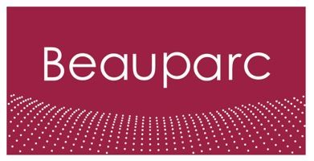
Job Description – Beauparc
Job Title | Regional Business Administrator
Reports to
Business/Function | Associated Waste Management
Primary Location | Associated Waste Management (AWM) - Valley Farm

Background: Join Beauparc, a distinguished environmental services company committed to pioneering waste management and recycling solutions. With a global footprint, Beauparc stands as a leader in sustainable practices, shaping a greener future for generations to come. Our dynamic work environment values innovation, collaboration, and a shared dedication to environmental responsibility.

Purpose: As a vital member of the Beauparc team, the Regional Business Administrator role holds a pivotal position in ensuring the seamless functioning of our daily operations. You will be at the forefront of maintaining efficiency across departments, contributing significantly to the overall success of Beauparc's mission. Your work will directly impact the effectiveness of our environmental initiatives, making your role both rewarding and essential.

Key accountabilities:
- Administrative Support: Provide essential day-to-day administrative support across diverse functions.
- Documentation and Record-Keeping: Uphold meticulous records, files, and databases to ensure accuracy and accessibility.
- Communication: Facilitate effective communication between internal teams and external stakeholders.
- Meeting Coordination: Contribute to the smooth execution of meetings, handling scheduling and documentation.
- Data Entry: Ensure accurate and timely entry of data into relevant systems.
- Office Management: Assist in the management of office supplies and resources to sustain operational efficiency.

Areas of responsibility:
- General Office Administration: Oversee and manage various general administrative tasks.
- Team Support: Provide crucial support to different teams, adapting to varied requirements.

Experience and Skills:
- Strong organisational and multitasking skills, with an ability to thrive in a fast-paced environment.
- Excellent communication skills to effectively liaise with team members and external contacts.
- Proficiency in the MS Office suite, ensuring adept handling of various administrative tasks.
- Meticulous attention to detail and commitment to maintaining accuracy in all tasks.

Qualifications and Knowledge:
Familiarity with basic office procedures and a keen interest in further developing administrative processes within the region

Beauparc aims to attract and retain a skilled and diverse workforce that best represents the talent available in the communities in which our assets are located and our employees reside.
(DE&I Policy Statement)

